Cloud-Enhanced Automatic Public Street Light System for Sustainable Urban Illumination

## MINI PROJECT (REVIEW2)

***Submitted by***

**BOOBESH PM-(212222233001)**

**GIFTSON RAJARATHINAM-(212222233002)**

**JEEVANESH-(212222233002)**

***in partial fulfilment for the award of the degree of***

# BACHELOR OF ENGINEERING

***in***

**COMPUTER SCIENCE AND ENGINEERING (INTERNET OF THINGS)**



**SAVEETHA ENGINEERING COLLEGE, THANDALAM**

**An Autonomous Institution Affiliated to**

# ANNA UNIVERSITY - CHENNAI 600 025

NOVEMBER 2024



ANNA UNIVERSITY, CHENNAI

# BONAFIDE CERTIFICATE

Certified that this Project report **“ REAL TIME VEHICLE COLLISION DETECTION WITH ALERT SYSTEM ”** is the bonafide work of **AKSHITH S (212222040115),** who carried out this project work under my supervision.

| SIGNATURE **Dr.G.Lavanya**  **Professor** SUPERVISOR Dept of Computer Science and Engineering,  Saveetha Engineering College, Thandalam, Chennai 602105 | SIGNATURE **Dr. G. Karthi, M.E., PhD**  **Professor** HEAD OF THE DEPARTMENT Dept of Computer Science and Engineering,  Saveetha Engineering College, Thandalam, Chennai 602105 |
| --- | --- |

DATE OF THE VIVA VOCE EXAMINATION: …………………………

## INTERNAL EXAMINER EXTERNAL EXAMINER

**ACKNOWLEDGEMENT**

I would like to express my heartfelt gratitude to our esteemed Founder President **Dr. N. M. Veeraiyan**, our President **Dr. Saveetha Rajesh**, our Director **Dr. S. Rajesh**, and the entire management team for providing the essential infrastructure.

I extend my sincere appreciation to our principal, **Dr. V. Vijaya Chamundeeswari, M.Tech., Ph.D.,** for creating a supportive learning environment for this project.

I am very thankful to our Dean of ICT, **Mr. Obed Otto,** M.E., for facilitating a conducive atmosphere that allowed me to complete my project successfully.

My thanks go to **Dr. G. Karthi**, Professor and Head of the Department of Computer Science and Engineering at Saveetha Engineering College, for his generous support and for providing the necessary resources for my project work.

I would also like to express my profound gratitude to my Supervisor, **Dr.G.Lavanya**, and my Project Coordinator **Dr. N.S. Gowri Ganesh**, Associate Professor at Saveetha Engineering College, for their invaluable guidance, suggestions, and constant encouragement, which were instrumental in the successful completion of this project. Their timely support and insights during the review process were greatly appreciated.

I am grateful to all my college faculty, staff, and technicians for their cooperation throughout the project. Finally, I wish to acknowledge my loving parents, friends, and well-wishers for their encouragement in helping me achieve this milestone.

# ABSTRACT

Urban infrastructure cannot function well without street lighting, which also affects energy use, traffic control, and public safety. Nevertheless, there are a number of drawbacks to the conventional approaches of streetlight maintenance, including extended failures brought on by burned-out bulbs, defective cabling, or isolated power disruptions. These malfunctions may go unreported for a long time, increasing the risk to public safety, particularly in places with heavy traffic or residential areas. Furthermore, in order to detect errors, these antiquated systems frequently rely on manual examination or postponed public reports. This method wastes extra energy and leads to inefficient maintenance cycles and increases operating expenses. By creating a smart, automated street lighting system that can identify and report problems in real time, this project seeks to remedy these deficiencies. The system makes use of contemporary sensor technology and the Internet of Things. (IoT) frameworks, and data analytics to continuously monitor the status of streetlights. By employing sensors to measure parameters such as light intensity, current flow, and power usage, the system can accurately detect issues like bulb failures or electrical faults. Data from the streetlights will be transmitted to a central monitoring hub, where advanced algorithms analyze the information to identify anomalies and predict potential failures.

To ensure scalability and efficiency, the project incorporates wireless communication protocols such as Zigbee or LoRa to facilitate real-time reporting of issues to maintenance teams. When a fault is detected, alerts will be automatically sent to maintenance personnel, enabling prompt action and reducing downtime. Furthermore, the system can be integrated with smart city platforms, allowing for energy-efficient operations such as dimming or switching off streetlights during low-traffic periods, thereby reducing overall energy consumption.

# TABLE OF CONTENTS

| **CHAPTER NO.** | | | **TITLE** | **Page**  **Number** |
| --- | --- | --- | --- | --- |
| **1** |  |  | **INTRODUCTION** |  |
|  | 1.1 | Overview of the project | 1 |
|  | 1.2 | Problem Definition | 2 |
| **2** |  |  | **LITERATURE SURVEY** | 3 |
| **3** |  |  | **SYSTEM ANALYSIS** |  |
|  | 3.1 |  | Existing System | 9 |
|  | 3.2  3.3  3.4 |  | Disadvantages Proposed System Advantages | 9  9  10  10 |
|  | 3.5 |  | Feasibility Study | 10 |
|  | 3.6 |  | Hardware Environment | 10 |
|  | 3.7 |  | Software Environment | 10 |
|  | 3.8 |  | Technologies Used | 10 |
|  |  | 3.8.1 | Python | 11 |
|  |  | 3.8.2 | Blynk Application | 11 |
| **4** |  |  | **SYSTEM DESIGN** |  |
|  | 4.1 |  | ER- Diagram | 12 |
|  | 4.2 |  | Data Flow Diagram | 13 |
|  | 4.3 |  | UML Diagram | 14 |
|  |  | 4.3.1 | Use Case Diagram | 14 |
|  |  | 4.3.2 | Class Diagram | 15 |
|  |  | 4.3.3 | Sequence Diagram | 16 |
| **5** |  |  | **SYSTEM ARCHITECTURE** |  |
|  | 5.1 |  | Architecture Diagram | 17 |
|  | 5.2 |  | Algorithms | 18 |
|  |  |  |  |  |
| **6** |  |  | **SYSTEM IMPLEMENTATION** |  |
|  | 6.1 | Implementation Process | 20 |
|  |  |  |  |
| **7** |  |  | **SYSTEM TESTING** |  |
|  | 7.1 | Flow chart | 23 |
|  |  |  |  |
| **8** |  |  | **CONCLUSION AND FUTURE** |  |
|  |  | **-ENHANCEMENT** |  |
|  | 8.1 | Conclusion | 26 |
|  | 8.2 | Future Enhancement | 27 |
| **9** | 9.1 |  | **APPENDIX-1**  Source Code | 28 |
| **10** |  |  | **APPENDIX-2** |  |
|  |  | Sample Output |  |
|  | 10.1 | Home Page | 35 |
|  |  | Detection with Details | 36 |
|  |  |  | Real Time Visualization  Alert Message | 37  38 |
| **11** |  |  | **REFERENCES** | 39 |

### LIST OF TABLES

**TABLE NO. TABLE DESCRIPTION PAGE NO.**

* + 1. Test Case For LDR Output 24
    2. Test Case For Search And Detect Sunlight Intensity

### LIST OF FIGURES

| **FIGURE NO.** | **FIGURE DESCRIPTION** | **PAGE NO.** |
| --- | --- | --- |
| 4.1 | Entity Relationship Diagram | 12 |
| 4.2.1 | Level 0 of Data flow Diagram | 13 |
| 4.2.2 | Level 1 of Data flow Diagram | 13 |
| 4.3.1 | Use Case Diagram | 14 |
| 4.3.2 | Class Diagram | 15 |
| 4.3.3 | Sequence Diagram | 16 |
| 5.1 | Architecture Diagram | 17 |
| 10.1 | Home Page | 35 |
| 10.2 | Detection With Details | 36 |
| 10.3 | Real Time Visualization | 37 |
| 10.4 | Alert Message | 38 |

viii

**LIST OF ABBREVIATIONS**

| **CNN** | Convolutional Neural Network |
| --- | --- |
| **LCNN** | Lookup based Convolutional Neural Network |
| **RNN** | Recurrent Neural Networks |
| **DEX** | Dalvik Executables |
| **TCP** | Transfer Control Protocol |
| **IP** | Internet Protocol |
| **HTTP** | Hyper Text Transfer Protocol |
| **ADT** | Android Development Tool |

**LIST OF SYMBOLS**

| **S.NO.** | **SYMBOL NAME** | **SYMBOL** |
| --- | --- | --- |
| 1. | Usecase |  |
| 2. | Actor |  |
| 3. | Process |  |
| 4. | Start |  |
| 5. | Decision |  |
| 6. | Unidirectional |  |
| 7. | Entity set |  |
| 8. | Stop |  |

# Chapter 1 INTRODUCTION

## OVERVIEW OF THE PROJECT

By establishing well-lit environments that discourage crime and make nighttime travel easier, street lights in rural areas are essential to inhabitants' safety and security. However, manual monitoring is frequently necessary for typical street lighting systems, which results in extended outages when lights malfunction because they are often overlooked or not reported. By employing resistors based on light (LDRs) to control lighting operations and identify malfunctioning lights, this research seeks to develop a smart, automatic public lights system that tackles these issues.

Two LDRs are used by the system to provide dual functionality. The street light can automatically turn on in the evening and turn off when sunlight returns in the morning thanks to LDR1's ability to detect ambient light levels. This feature lowers operating expenses and energy usage by doing away with the requirement for

In addition, LDR2 continuously monitors each light’s functionality. If a light malfunctions, LDR2 identifies the defect and transmits data to a central monitoring system, including the exact location of the defective unit. This real-time defect detection feature is especially beneficial in rural areas, where populations may be sparse, and faulty lights could go unreported for extended periods. By ensuring prompt maintenance, this system helps to maintain consistent lighting, thereby enhancing safety and reducing incidents of harassment or theft in darkened areas.

Overall, this automated street lighting system offers a reliable, energy-efficient, and self-monitoring solution for both urban and rural settings.

#### PROBLEM DEFINITION

Street lighting plays a critical role in public infrastructure in contemporary urban areas, assuring safety, improving road user visibility, and improving general quality of life. Despite their significance, traditional street lighting systems have a number of operational issues because of ineffective maintenance procedures and a deficiency of real-time monitoring tools. Frequently, these systems depend on manual examinations or open-access reports to detect problems like burned-out lightbulbs, malfunctioning wiring, or power disruptions. Because of this reactive strategy, streetlights are out of commission for extended periods of time, which raises the risk to public safety, energy consumption, and operating expenses.

The delayed notification of faults is the first issue with standard street lighting systems. When a streetlight fails, there is no automated system set up to alert maintenance staff. Instead, unless there is a scheduled personal examination or a citizen discovers the issue, the issue remains unaddressed. This delay frequently leads to prolonged outages, especially in isolated or less populated locations, which could leave streets dimly illuminated for extended periods of time. Dark streets increase the chance of accidents, criminal activity, and other dangers for both drivers and pedestrians. The efficacy of urban lights systems is weakened and public safety is jeopardised by delayed problem identification.

Another significant challenge is the high cost and inefficiency of manual inspection processes. In most cities, maintenance teams are responsible for routinely inspecting thousands of streetlights. This labor-intensive task requires significant resources in terms of personnel, time, and equipment. Furthermore, due to the scale of these networks, it is often difficult for maintenance teams to respond promptly to all reported issues. As a result, faulty streetlights can remain unattended for days or even weeks, depending on the severity and location of the problem. This inefficiency leads to increased maintenance costs and reduced service reliability for municipalities.

In addition to maintenance inefficiencies, conventional street lighting systems contribute to unnecessary energy waste. Traditional streetlights typically operate at full intensity throughout the night, regardless of the actual need for lighting. This static approach to lighting fails to consider variables such as pedestrian and vehicular traffic patterns, which fluctuate during the night. As a result, energy is wasted by keeping lights on in areas that may not require full illumination. With growing concerns about energy conservation and sustainability, there is a pressing need for more adaptive street lighting solutions that adjust according to real-time conditions, helping cities reduce their environmental footprint while lowering operational costs.

The lack of integration between street lighting and smart city initiatives further limits the potential for optimizing urban infrastructure. In an era where cities are increasingly turning to technology to improve the efficiency of public services, street lighting remains one of the most underutilized resources. By failing to incorporate sensors, real-time data analytics, and wireless communication systems, traditional streetlights miss the opportunity to contribute to broader smart city goals. A more intelligent system would allow for centralized control, enabling city administrators to monitor and manage streetlights remotely, diagnose problems, and deploy maintenance teams more effectively.

# Chapter 2 LITERATURE SURVEY

## INTRODUCTION

A literature survey or a literature review in a project report is that section which shows various analysis and research made in the field of your interest and the results already published, taking into account the various parameters of the project and the extent of project. Once the programmers start building the tool programmers need a lot of external support. This support can be obtained from senior programmers, books or from the websites. It is the most important part of your report as it gives you a direction in the area of your research. It helps you set a goal for your analysis - thus giving you your problem of statement. Literature survey is the most important sector in the software development process. Before developing the tools and the associated designing the software it is necessary to determine the survey the time factor, resource requirement etc., The consumer needs regarding online customer service differs from person to person. The needs are also based off each persons personal needs. We need to identify and anticipate these needs in order to completely and accurately meet them.

## LITERATURE SURVEY

#### A comprehensive survey on an IoT-based smart public street lighting system application

**Author Name :** Siwar, Khemakhem., Lotfi, Krichen

#### Year of Publish : 2024

This paper explores the development of smart public street lighting systems for IoT-enabled smart cities, focusing on the transition from traditional lighting to energy-efficient LED technology. It highlights the integration of wireless sensors and controllers for dynamic brightness control, offering significant energy savings. The study emphasizes the importance of IoT infrastructure, including smart poles, sensors, communication networks, and monitoring units, to enhance urban functionality. Challenges include ensuring device communication, secure data management, and system scalability. Despite these hurdles, the system promises improvements in energy efficiency, safety, and sustainability, with attention needed on cost, data security, and maintenance for successful implementation.

#### Real-Time Tracking Street Light Monitoring and Control.

**Author Name :** Martin, Dejanov., Nikolay, Valov., Stoyan, Nyagolov.

#### Year of Publish : 2024

The paper introduces an intelligent street lighting system using open-source hardware and software to control light fixture intensity based on real-time traffic data. The system allows centralizedmonitoring and incorporates algorithms to improve energy efficiency. Over a one-month test period, the system achieved a 31.6% reduction in energy consumption. However, energy savings may fluctuate depending on traffic patterns and street load. The system demonstrated stability and effectiveness in energy savings, with potential for further optimization based on traffic variability.

#### Fault Detection Using ‘LDR’ sensor:

**Author Name :** T., Gopinath., Dr., Princess, maria, john.

#### Year of Publish : 2024

An Arduino Uno board with IR and LDR sensors are used in the "IoT-Based Smart Street Lamp System" to create an energy-effective street lighting system. To avoid wasting electricity, the system automatically modifies the state of street lights based on the amount of light and the number of vehicles. While the IR device recognises obstacles or moving cars and turns lights up or down in response, the LDR sensor regulates brightness. When cars come or obstruct the sensor's route, for example, the system makes sure that lights only turn on when necessary. During daylight hours or periods of low traffic, its adaptive control minimises superfluous lights and maximises energy use.

#### Street light using cloud computing

**Author Name :** Mukesh, M.., Ajay, B., M.., Arun, Prakash

#### Year of Publish : 2023

The Smart Street Lighting control system, integrated with cloud-based Central Management System (CMS) software, allows efficient monitoring and control of large-scale outdoor lighting networks. It supports the Smart City initiative by enabling scheduled lighting, adjustable dimming, and real-time detection of malfunctions, reducing energy consumption and maintenance costs. Through web-based access, operators can manage lighting settings automatically or manually. Cities worldwide are increasingly adopting this IoT-based lighting solution, replacing traditional infrastructure to improve energy efficiency and operational reliability. Designed for diverse applications, from urban streets to highways, CCMS provides remote lighting control, tailored scheduling, and energy monitoring.

#### Smart Street Lighting Control System Using PWM.

**Author Name :** Om, Parhad., Sarthak, Kumar..

#### Year of Publish : 2023

The IoT-based smart street light system aims to conserve energy by automating street light control and reducing manual labor. It uses an LDR sensor to detect ambient light levels, automatically turning lights on and off based on daylight. The system's status can be monitored remotely through the internet, ensuring reliable and stable operation. A programmable board adjusts light intensity throughout the day for optimal energy use. Compared to traditional systems, this approach offers enhanced energy efficiency and performance

#### IoT Based Automated Street Light Reporting System.

**Author Name :** Anchitaalagammai., Syariful.

#### Year of Publish : 2023

The effect of the Internet of Things (IoT), specifically in relation to smart street lighting systems, on the development of smart cities is examined in this article. To further maximise energy use, these devices detect the status of people or cars and modify light brightness based on ambient light. Additionally, they are able to detect malfunctioning street lights and transmit maintenance information to the cloud. Cities can build more sustainable and effective infrastructure by combining these systems into a single IoT platform. Reduced energy use, financial savings, a lower carbon impact, and better maintenance thanks to control and monitoring via the internet are some advantage

## LITERATURE SURVEY SUMMARY

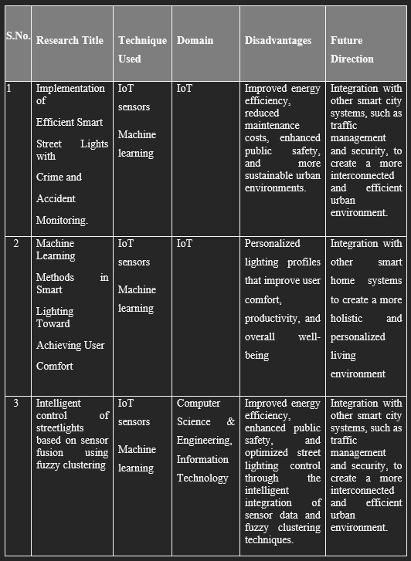

# Chapter 3 SYSTEM ANALYSIS

* 1. **EXISTING SYSTEM**

The current streetlight maintenance system is largely reactive, relying on manual inspections or delayed public reporting to identify failures. This results in inefficient resource allocation, extended downtime of malfunctioning streetlights, and increased operational costs. The absence of real-time fault detection prolongs the periods where streetlights remain inoperative, creating safety hazards for pedestrians and drivers, especially in high-traffic or poorly monitored areas.

Moreover, conventional systems lack energy optimization, as streetlights are often kept at full brightness throughout the night, leading to unnecessary energy consumption and higher costs.

The proposed system addresses these inefficiencies by introducing automation through IoT sensors and real-time monitoring. These technologies enable continuous surveillance of streetlight performance, immediately detecting malfunctions like burnt-out bulbs, wiring faults, or power outages. By transmitting real-time data via wireless networks to a central control system, the proposed solution ensures that maintenance teams can respond quickly to issues, significantly reducing downtime.

Additionally, adaptive lighting, powered by motion and traffic sensors, optimizes energy usage by adjusting brightness based on current activity levels, leading to significant energy savings.

## DISADVANTAGES OF EXISTING SYSTEM

* High Energy Consumption: Traditional streetlights are often left on throughout the night, regardless of traffic or pedestrian activity, leading to excessive energy use and higher operational costs.
* Manual Maintenance and Inspection: Regular inspections are typically required to identify issues like bulb burnout or wiring problems, which is labor-intensive, time-consuming, and often leads to delays in repairs.
* Lack of Real-Time Monitoring: Without continuous monitoring, issues may go undetected until a physical inspection, increasing response times and downtime for faulty lights.

## PROPOSED SYSTEM

The proposed system aims to transform traditional street lighting with a smart, automated solution to improve fault detection, maintenance, and energy efficiency. By integrating IoT technology, each streetlight will have sensors to monitor light intensity, current flow, and voltage, enabling real-time status checks and automatic detection of malfunctions like burnt-out bulbs or wiring faults. When a fault is identified, the system will instantly generate a report and use wireless communication (such as Zigbee or LoRa) to notify a central control hub, which analyzes the data and prioritizes maintenance by fault severity and location. Maintenance teams receive real-time alerts on mobile devices or control dashboards, enabling rapid responses and reducing downtime without relying on manual inspections. To conserve energy, the system includes adaptive lighting controls that adjust brightness based on real-time traffic or pedestrian activity—dimming lights in low-traffic hours and brightening them when needed. This feature minimizes energy consumption, cuts operational costs, and supports sustainability goals. Designed to be scalable and modular, the system integrates easily with other smart city technologies, such as traffic management, environmental monitoring, and public safety networks, providing administrators a comprehensive view of urban infrastructure. By combining real-time monitoring, automated fault detection, adaptive lighting, and smart city integration, the system aims to enhance street lighting reliability, lower maintenance costs, improve public safety, and promote energy conservation.

#### ADVANTAGES OF PROPOSED SYSTEM

* Improved Efficiency and Rapid Maintenance: The system’s real-time monitoring and automated fault detection reduce dependency on manual inspections, allowing maintenance teams to respond promptly to issues, minimizing downtime, and ensuring that streetlights remain functional for public safety.
* Enhanced Energy Savings: Adaptive lighting controls adjust brightness based on traffic and pedestrian activity, leading to significant reductions in energy consumption during low-traffic hours, which lowers operational costs and supports sustainable energy use.
* Seamless Integration and Scalability: The modular design allows easy integration with other smart city technologies, enabling a holistic approach to urban management and making it scalable for deployment across cities and regions.

#### FEASIBILITY STUDY

With the growing use of IoT technologies in urban infrastructure, a stored in the cloud Smart Street Lighting management system with software like CMS is highly feasible. Although it necessitates an initial investment in infrastructure and technological advancements, the long-term savings in energy and lower costs of upkeep make it cost-effective. Cities looking to modernise and centralise lighting control will benefit from its versatility and remote access capabilities. The system is also compatible with international Smart City projects, which makes it a sensible option for local governments everywhere.

#### HARDWARE ENVIRONMENT

Processor : Pentium Dual Core 2.00GH

Hard disk : 120 GB

RAM : 2GB (minimum)

Keyboard : 110 keys enhanced

#### SOFTWARE ENVIRONMENT

Operating system : Windows7 (with service pack 1), 8, 8.1 ,10 and 11

Language : Python

#### TECHNOLOGIES USED

IDE - Visual Studio

Application - blynk app

#### Python

Python is a high-level, interpreted programming language that is widely used in various domains such as web development, data science, artificial intelligence, scientific computing, and more. It was first released in 1991 and has since become one of the most popular programming languages in the world. Some key features of Python include:

Easy to Learn: Python has a simple and easy-to-learn syntax, which makes it an ideal language for beginners.

Interpreted Language: Python is an interpreted language, which means that the code is executed line by line, making it easier to test and debug.

Cross-Platform: Python can be run on various platforms, including Windows, macOS, and Linux.

Large Standard Library: Python has a large standard library that provides a wide range of built-in modules for various tasks, such as file I/O, regular expressions, networking, and more.

Open Source: Python is open-source software, which means that the source code is freely available to anyone and can be modified and redistributed.

Object-Oriented: Python is an object-oriented language, which means that it supports object-oriented programming concepts such as encapsulation, inheritance, and polymorphism.

## Blynk Application:

Blynk is a powerful and user-friendly Internet of Things (IoT) platform that allows users to easily create mobile applications for controlling and monitoring IoT devices like microcontrollers, sensors, and embedded systems. It supports popular hardware such as Arduino, ESP8266, ESP32, and Raspberry Pi, making it a versatile choice for various IoT projects. Blynk consists of three main components: the Blynk app (available on iOS and Android), the Blynk server, and the Blynk library. The app serves as a user interface where users can add widgets, such as buttons, sliders, and gauges, to control devices or view data in real-time. The server manages communication between the app and the connected devices, and users can opt to use Blynk's public cloud server or a private local server for more control over data and performance. The Blynk library integrates with the hardware, allowing it to communicate seamlessly with the Blynk server. Blynk is widely used in applications ranging from home automation to industrial monitoring and educational projects, offering capabilities like real-time control, data visualization, and remote notifications. The platform is popular for its ease of use, as it allows both beginners and professionals to build connected applications quickly without extensive programming skills.

# Chapter 4 SYSTEM DESIGN

#### ENTITY-RELATIONSHIP DIAGRAM

This entity diagram represents the structure of a smart streetlight system1. It includes three main entities: Cloud, MCU (Microcontroller Unit), and LDR1 (Light Dependent Resistor sensor)2. The Cloud entity handles data storage and management, with attributes like storage and database, and methods such as data management() and traffic control()3. The MCU acts as the central controller, managing hardware and connections, and includes the method send electronic signals() to communicate with both the cloud and the sensor4. The LDR1 entity represents a light sensor, with attributes to measure light intensity and methods like detect light() and change resistance based on light intensity()5. The diagram shows interactions where the cloud communicates with the MCU, and the MCU interacts with the LDR sensor, facilitating an automated streetlight system

**Fig 4.1 Entity Relationship Diagram**

* 1. **DATA FLOW DIAGRAM (DFD)**

This flow diagram illustrates the process for an automated lighting system with IoT capabilities. The Wi-Fi module starts by transmitting data to an IoT platform, and the system measures temperature, sending this data via the Wi-Fi module. An LDR (Light Dependent Resistor) then checks the ambient brightness level to determine if it is dark. If it is dark, the system proceeds to check if it is bright again. If it is not bright, the bulbs remain on; otherwise, they are switched off. If it is not dark initially, the bulbs remain off, looping back to recheck conditions.

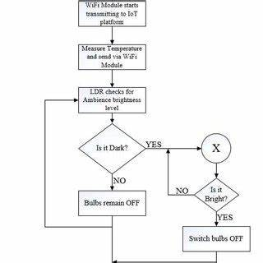

**FLOW DIAGRAM**

#### UML DIAGRAMS

* + 1. **Use Case Diagram**

This use case diagram illustrates an automated street light system with cloud storage integration. The system includes a microcontroller unit (MCU) responsible for managing sensors and controlling the bulbs in the streetlight system. A current supply powers the system, which enables the MCU to interact with different components. Two light-dependent resistors (LDR1 and LDR2) are used as sensors to detect ambient light levels, allowing the MCU to adjust the lighting accordingly. Data from the MCU can be stored in cloud storage, enabling remote access to system data and control. The streetlight system receives commands from the MCU to turn bulbs on or off based on sensor inputs and pre-set conditions. This setup enables efficient, automated control of streetlights and provides access to operational data for monitoring and analysis.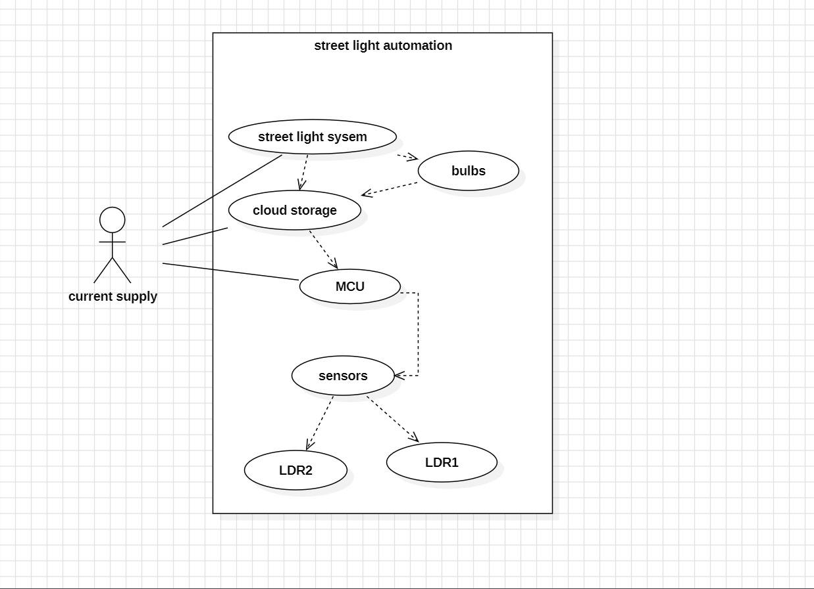

#### Class Diagram

This class diagram represents the structure of a smart streetlight automation system. It includes three main classes: Cloud, MCU (Microcontroller Unit), and LDR1 (Light Dependent Resistor sensor).

The Cloud class has attributes like `storage` and `database`, which handle data storage and management for the system. It includes methods like `data management()` and `traffic control()` to manage and analyze data from the streetlights.

The MCU class acts as the central controller with attributes such as `controlling the hardware` and `connections`. It has a method `send electronic signals()` that communicates with both the cloud and the sensor (LDR1) to manage the system based on sensor input.

The LDR1 class represents a light sensor with attributes like `measure the intensity`. It includes methods like `detect light()` and `changes resistance based on light intensity()`, which adjust its resistance according to the ambient light, allowing the MCU to decide when to turn streetlights on or off.

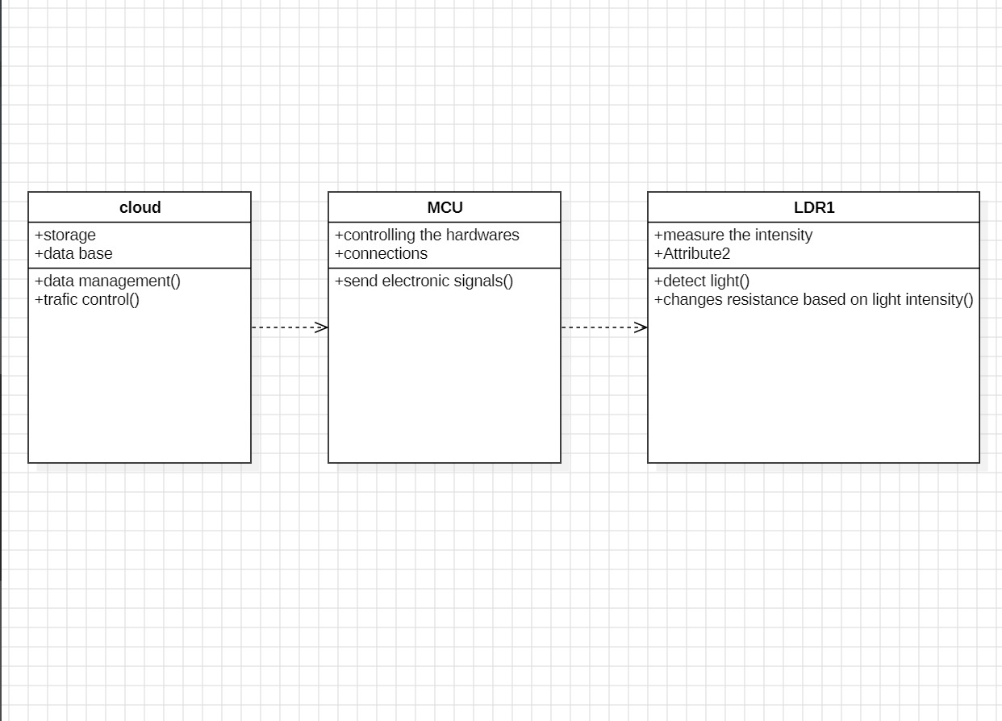

#### Sequence Diagram

1. **Data Transfer :** The process starts with the 'cloud' sending data to the 'MCU' (Microcontroller Unit).

2. **Signal to LDR :** The 'MCU' then signals the 'LDR' (Light Dependent Resistor).

3. **Fault Check** : If no fault is detected, the 'MCU' checks for defects and reports back to the 'cloud'.

4. **Fault Detected** : If a fault is detected, a "fault detected" message is sent to the 'cloud'.

5. **Confirmation :** The sequence ends with a processing delay and confirmation signal between 'MCU' and 'LDR'.

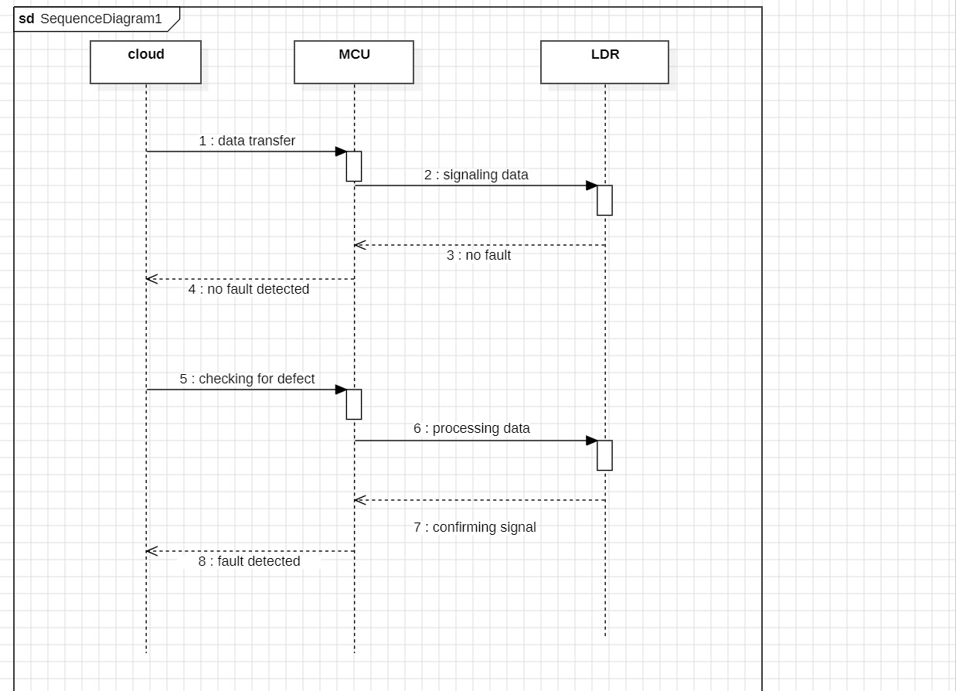

# Chapter 5

**SYSTEM ARCHITECTURE**

## ARCHITECTURE DIAGRAM

This architecture diagram shows a smart streetlights system that controls and monitors streetlights using a microcontroller (such as an Arduino or ESP32). An AC/DC electrical supply powers the system, supplying electricity to the streetlights and microprocessor. Numerous sensors provide data to the microcontroller, such as a voltage sensor to track voltage levels, a sensor for current (ACS712) for determining power consumption, and a sensor for light (LDR) to detect daylight levels. Individual streetlights (designated as Streetlights 1, 2, and 3) can be turned on or off by the microcontroller based on the readings.

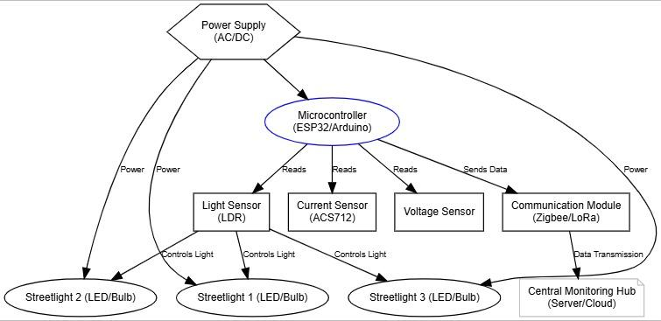

Fig 5.1 Architecture Diagram

The Data transfer to a centralised monitoring hub—which might be a server or a cloud service for remote surveillance and control—is made possible by a communication module, like Zigbee or LoRa.. This setup enhances energy efficiency and allows for real-time monitoring and management

#### ALGORITHMS

This program is designed to monitor a streetlight system using the Blynk IoT platform and an ESP8266 microcontroller. It initializes the Blynk library to allow the device to connect to Blynk’s cloud, where it can send sensor data and receive control commands. The setup begins by defining authentication credentials for Blynk, Wi-Fi configuration (SSID and password), and specifying digital pins for the streetlights (r1, r2, r3) and an input pin for a light-dependent resistor (LDR) sensor.

In the `setup()` function, the program initializes serial communication for debugging and sets the pin modes for the streetlights as outputs and the LDR sensor as an input. It then establishes a connection to the Blynk cloud using `Blynk.begin()`, enabling remote control and data visualization. A Blynk timer is set with a 1-millisecond interval to repeatedly execute the `sendSensor()` function, which reads sensor values and controls the streetlights accordingly.

The `sendSensor()` function reads analog input from the first LDR (ldr1) and a digital input from the second LDR (ldr2). If the light intensity is low (indicated by `ldr1` reading above a threshold of 800), the streetlights (r1, r2, r3) are turned off. If the second LDR (`ldr2`) detects a fault, a `fault` flag is set to 1, indicating an issue with the system. This fault status is then sent to the Blynk app using `Blynk.virtualWrite(V0, fault)`, allowing for remote fault monitoring.

The `loop()` function continuously runs `Blynk.run()` to process Blynk events and `timer.run()` to repeatedly call the `sendSensor()` function. Additionally, a helper function, `getValue()`, is provided to split a string based on a specified separator and index, which can be useful for parsing data received from Blynk or other sources. This program allows real-time monitoring and control of streetlights, including fault detection, by utilizing the Blynk IoT platform.

# Chapter 6

**SYSTEM IMPLEMENTATION**

## MODULE 1: Implementation Processing

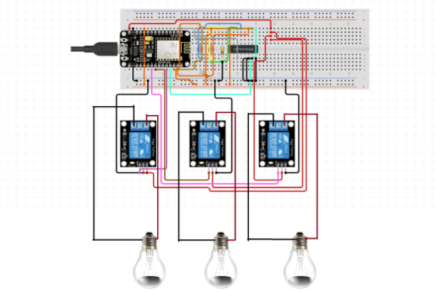

This image illustrates a circuit setup on a breadboard that controls three light bulbs through a microcontroller and relay modules. The microcontroller, which appears to be an ESP8266 or similar Wi-Fi-enabled board, is powered via a USB connection. It is connected to three relay modules, each responsible for switching one of the bulbs on or off.

The relays are connected to the digital output pins of the microcontroller, allowing it to control each relay individually based on programmed conditions. Each relay has three main connections: a common (COM), normally open (NO), and normally closed (NC) terminal. The wiring suggests that the circuit is configured so the microcontroller can open or close the circuit to each bulb independently through the NO terminal, allowing control over the lighting.

The light bulbs are connected in such a way that when the relay is triggered, the circuit completes, allowing current to flow and the bulb to turn on. This setup is typical in IoT applications, where the microcontroller could connect to a platform like Blynk to enable remote or automated control of the lights based on environmental conditions or user inputs. This configuration could be part of a smart lighting system, where each light can be independently monitored and controlled remotely for energy-saving purposes.

. **Chapter 7**

**SYSTEM TESTING**

#### Flow Chart

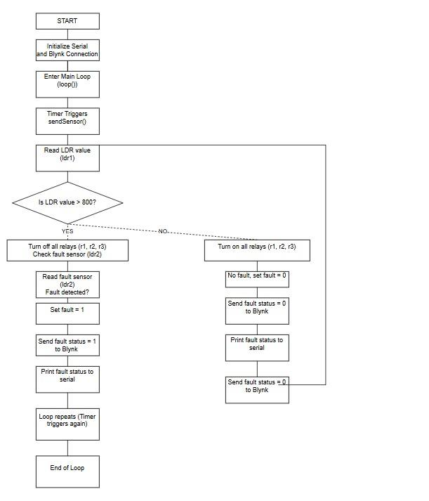

Fig 7.1 Flow Chart

This flowchart illustrates the operation of an automated fault-detection and light control system using a microcontroller and a Light Dependent Resistor (LDR). The system starts by initializing the Serial communication and establishing a connection to the Blynk platform for IoT-based monitoring. Once initialized, the system enters the main loop where it continuously monitors the status of the lights and detects faults.

The main function in the loop is triggered by a timer, which calls the `sendSensor()` function periodically. The first step is to read the value from the LDR sensor (`ldr1`). This sensor checks the ambient light intensity. If the LDR value is greater than 800, indicating a dark environment, the system proceeds to turn off all the relays (`r1`, `r2`, and `r3`), meaning the lights are turned off. It then checks the fault sensor (`ldr2`) to detect any possible issues with the lighting.

If the fault sensor detects a problem (like a malfunctioning light), the fault status is set to 1. This fault status is then sent to the Blynk platform and printed on the Serial monitor, allowing remote monitoring of the issue. If no fault is detected, the system sets the fault status to 0 and continues operation.

When the LDR value is below 800, indicating a brighter environment, the system turns on all relays (`r1`, `r2`, and `r3`) to activate the lights. It checks for faults again, and if none are found, it sets the fault status to 0, updates this status on Blynk, and prints the information to the Serial monitor. This loop continues indefinitely, ensuring real-time monitoring and control of the lights, and sending status updates to the Blynk platform for continuous supervision of the lighting system and prompt fault detection.

* 1. **TEST CASES TEST REPORT: 01**

**PRODUCT:** REAL TIME DEFECT DETECTION USING lDR

**USE CASE:** UPLOAD VIDEO

| TEST CASE ID | TEST CASE/ ACTION TO BE PERFORMED | EXPECTED RESULT | ACTUAL RESULT | PASS/FAIL |
| --- | --- | --- | --- | --- |
| 01 | LDR work in check | Light Off | As Expected | PASS |

**Table-7.3.1 Test Case For LDR Output.**

## TEST REPORT: 02

**PRODUCT:** REAL TIME STREET LIGHT TESTING

**USE CASE:** DETECT AND ALERT

| TEST CASE ID | TEST CASE/ ACTION TO BE PERFORMED | EXPECTED RESULT | ACTUAL RESULT | PASS/FAIL |
| --- | --- | --- | --- | --- |
| 01 | Detect the sunlight and the intensity | Detected Successfully | As Expected | PASS |
| 02 | Alerting message Through SMS | Send Successfully | As Expected | PASS |

**Table-7.3.2 Test Case For Search And Detect Sunlight Intensity**

# Chapter 8

**CONCLUSION AND FUTURE ENHANCEMENT**

## CONCLUSION

Finally, we demonstrated the viability and efficiency of using IoT and cloud technology for managing urban infrastructure by successfully implementing a cloud-enhanced automated public street light system. This creative system demonstrated the potential advantages of such strategies for sustainable urban development by achieving notable energy savings, lower maintenance costs, and improved public safety.

In the future, the system's integration with other smart city infrastructure elements, the investigation of advanced machine learning techniques for proactive upkeep, and the resolution of possible privacy and security issues could be the key areas of research and development. By taking these steps, the system's capabilities would be further improved and its alignment with changing urban needs would be guaranteed.

In conclusion, this automated street lighting system represents a significant advancement in enhancing safety, security, and energy efficiency, particularly in rural areas. By using two LDR sensors, it addresses common challenges associated with traditional street lighting systems, such as the need for manual monitoring and delayed response to malfunctions. LDR1 enables automatic control by detecting ambient light levels, turning the lights on at dusk and off at dawn, which reduces energy consumption and operational costs. Meanwhile, LDR2 monitors each light's functionality, allowing the system to detect and report faults in real time. This immediate detection and reporting mechanism is especially useful in remote areas, where light malfunctions might otherwise go unnoticed. The centralized monitoring system ensures that defective units are promptly identified and maintained, providing continuous illumination and enhancing public safety. Overall, this smart street lighting solution offers a reliable, cost-effective, and self-sustaining way to keep communities safer and reduce energy usage.

## FUTURE ENCHANCEMENT

Integration of AI and Predictive Maintenance: Future systems could incorporate artificial intelligence (AI) and machine learning algorithms to predict potential streetlight malfunctions before they occur. By analyzing historical data and sensor inputs, the system could forecast failures and trigger proactive maintenance, reducing downtime and operational costs.

Expansion of IoT Device Integration: To further enhance real-time monitoring and performance optimization, the system could integrate additional IoT sensors (e.g., environmental data like air quality, weather conditions, traffic patterns) to optimize streetlight behavior dynamically. This could improve energy savings, reduce light pollution, and enhance public safety based on real-time environmental conditions

Future enhancements to the proposed smart street lighting system could focus on integrating artificial intelligence (AI) and machine learning to enable predictive maintenance. By analyzing historical data and real-time sensor inputs, AI algorithms could forecast potential streetlight malfunctions—such as bulb failures, power fluctuations, or wiring issues—before they actually occur. This predictive capability would allow the system to anticipate faults and automatically initiate proactive maintenance scheduling, thus minimizing downtime and lowering operational costs associated with unexpected repairs. Maintenance teams would be able to address potential issues during routine inspections, rather than responding reactively to malfunctions, leading to a more streamlined and cost-effective maintenance process.

In addition to AI-driven predictive maintenance, the system could be further enhanced by expanding the integration of Internet of Things (IoT) devices. Beyond basic lighting control, additional IoT sensors could be installed on streetlights to monitor environmental factors like air quality, weather conditions, and traffic patterns in real time. This broader sensor network would enable the system to optimize streetlight behavior dynamically, adapting light intensity based on a range of environmental inputs. For example, during clear nights with low pedestrian or vehicle traffic, the system could dim lights to reduce energy use and light pollution. Conversely, during foggy or adverse weather conditions, the lights could increase in brightness to improve visibility and safety. With these enhancements, the streetlight system would not only contribute to energy efficiency and cost savings but also support public safety and environmental quality, aligning with broader smart city and sustainability goals. Through advanced AI the future system would evolve into a highly adaptive infrastructure asset, responsive to both predictive analytics and real-time urban conditions.

# Chapter 9

**APPENDIX 1 – SAMPLE CODING**

## accident-classification.ipynb:

//define Authentications from blynk

#define BLYNK_TEMPLATE_ID "TMPL3BF-9rs0O"

#define BLYNK_TEMPLATE_NAME "Street light fault indicator"

#define BLYNK_AUTH_TOKEN "yiYslMz6K1LeqjQzAyUQDIKvxjxfZVGT"

#define BLYNK_PRINT Serial //library for blynk

#include <ESP8266WiFi.h> //library for

Wi-Fi Configure

#include <BlynkSimpleEsp8266.h> //library for

simple coding interface on blynk

// Connection Configuration

char auth[] = BLYNK_AUTH_TOKEN;

char ssid[] = "iotadmin"; //Enter

your WIFI name

char pass[] = "12345678"; //Enter your

WIFI password

BlynkTimer timer; //Timer function

#define r1 D5

#define r2 D6

#define r3 D7

int ldr1=0,ldr2=0,fault=0;

//user defined function for send data to iot using timer

void sendSensor()

{

ldr1=analogRead(A0);

ldr2=digitalRead(D2);

if(ldr1>800){

digitalWrite(r1,LOW);

digitalWrite(r2,LOW);

digitalWrite(r3,LOW);

if(ldr2==1){

fault=1;

}

else{

fault=0;

}

}

else{

digitalWrite(r1,HIGH);

digitalWrite(r2,HIGH);

digitalWrite(r3,HIGH);

}

Serial.println(fault);

Blynk.virtualWrite(V0, fault) ;

}

// Arduino setup function

void setup() {

Serial.begin(9600);

pinMode(r1,OUTPUT);

pinMode(r2,OUTPUT);

pinMode(r3,OUTPUT);

pinMode(D2,INPUT);

timer.setInterval(1L, sendSensor);

//Initialize Blynk function from library

Blynk.begin(auth, ssid, pass, "blynk.cloud", 80); //WiFi get

Connected here to Blynk cloud

}

//Arduino main funciton

void loop() {

Blynk.run(); //run blynk

instructions

timer.run(); //Timer

function runs looped here

}

//function to split a string using character seperator

String getValue(String data, char separator, int index)

{

int found = 0;

int strIndex[] = { 0, -1 };

int maxIndex = data.length() - 1;

for (int i = 0; i <= maxIndex && found <= index; i++) {

if (data.charAt(i) == separator || i == maxIndex) {

found++;

strIndex[0] = strIndex[1] + 1;

strIndex[1] = (i == maxIndex) ? i+1 : i;

}

}

return found > index ? data.substring(strIndex[0], strIndex[1]) : "";

}

# Chapter 10

# APPENDIX 2 – SAMPLE OUTPUT

## 10.1 Home Page

The project output screenshots are shown as follows:



#### Homepage

The the homepage of the Blynk app, designed for managing a street light automation system via WiFi connectivity. The interface is clean and user-friendly, featuring a status bar at the top with connectivity indicators and battery status. Below, the app displays the “Street light fault indicator” with a green dot, signifying active monitoring. An icon of a street light with an alert symbol highlights the app’s focus on real-time fault detection. This setup allows users to remotely monitor and control street lights, ensuring efficient maintenance and quick response to any issues. The simplicity and functionality of the app make it ideal for municipal services managing public lighting systems

## Detection with Details

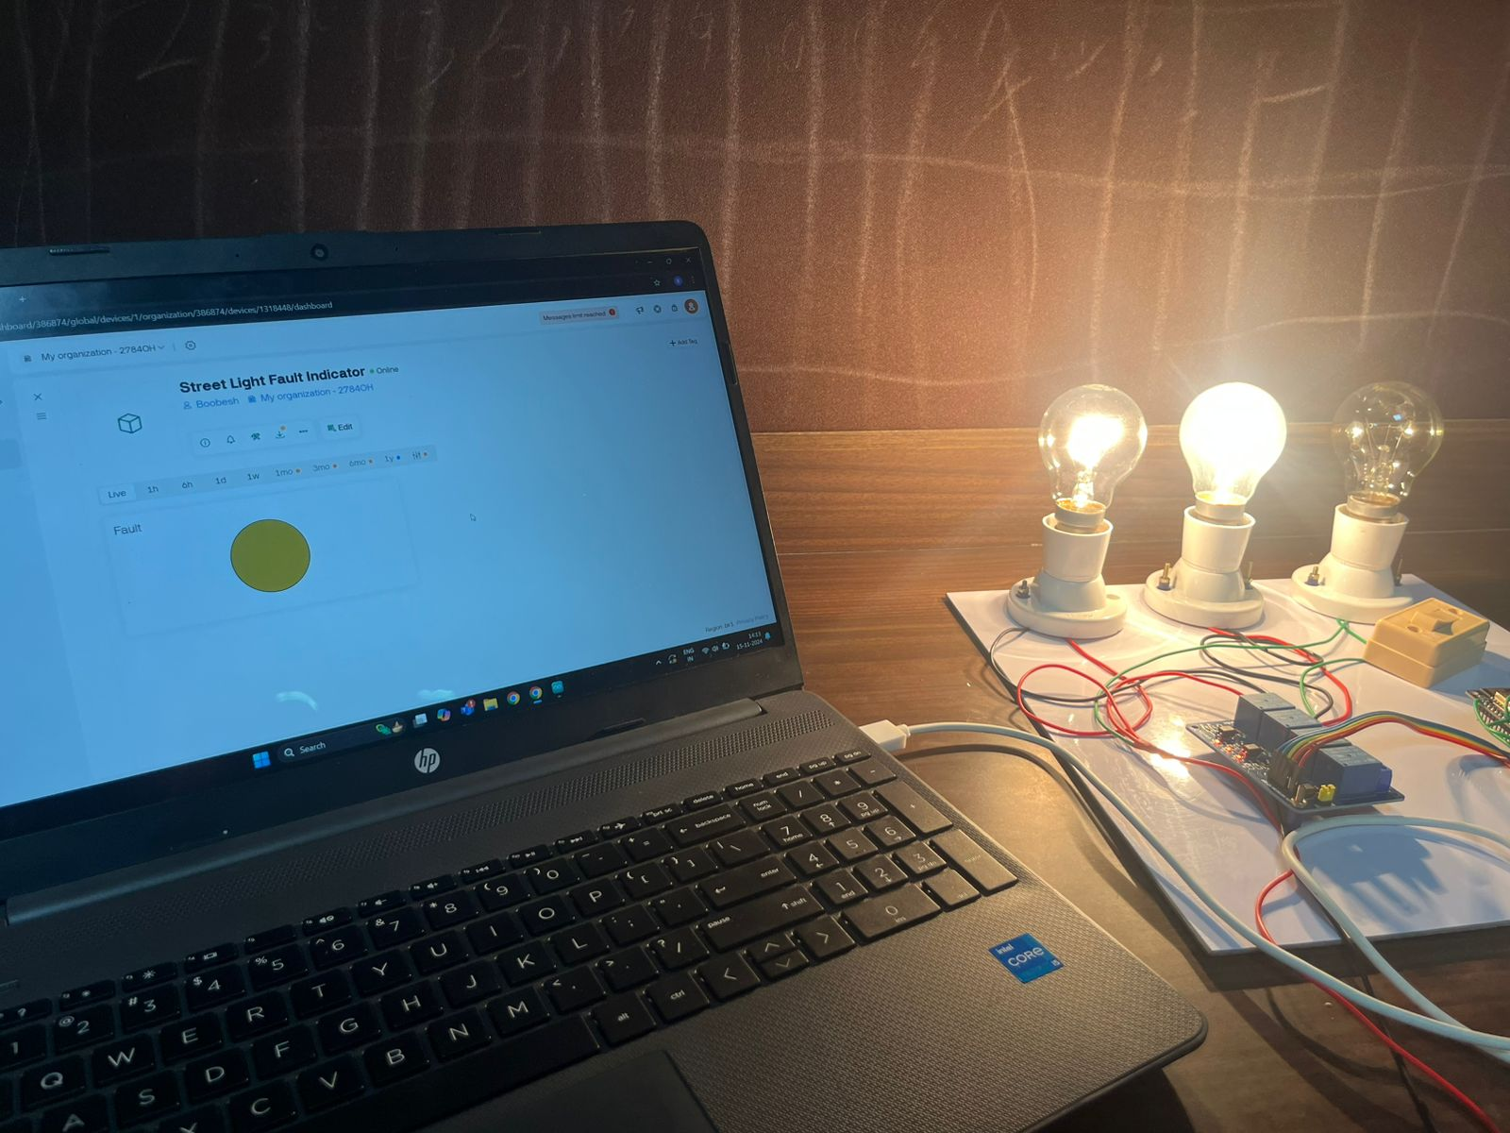

#### Detection With Details

The image illustrates a smart light system where an LDR (Light Dependent Resistor) detects a defect in the light. This information is then transmitted through the Blynk application, which is displayed on the laptop screen. The setup includes three light bulbs connected to a circuit board, demonstrating how the system monitors and reports the status of the lights. The Blynk app facilitates remote monitoring and control, ensuring efficient management of street lights by alerting users to any faults detected by the LDR.

## Real Time Visualization



#### Real Time Visualization

In this image, all the lights are on, indicating that the system is functioning correctly. The LDR (Light Dependent Resistor) detects the light levels and confirms that there are no issues. This information is then sent to the Blynk application, which updates the status to show that no defects are found. The setup includes a circuit board connected to the lights and the LDR, demonstrating the real-time monitoring capabilities of the system. The Blynk app provides a user-friendly interface for remote management and ensures efficient operation of the street light automation system.

## Alert Message



#### 10.4 Alert Message

The image displays a smartphone screen with the Blynk app open, indicating a problem with the street light system. The app shows an alert titled “Street light fault indicator,” accompanied by an icon of a street light with an alert symbol. This setup involves an LDR (Light Dependent Resistor) that monitors the light levels of the street lights. When the LDR detects an issue, such as a malfunction or a light being out, it sends this information to the microcontroller unit (MCU). The MCU processes this data and communicates with the Blynk app via WiFi. The Blynk app then displays a real-time alert to notify the user of the detected fault. This immediate notification allows for quick response and troubleshooting, ensuring that the street light system is maintained efficiently. The integration of the LDR, MCU, and Blynk app provides a robust solution for monitoring and managing street lights, enhancing public safety and service reliability.

Displaying an alert message titled “Street light fault indicator.” This indicates that the system has detected a problem with one of the street lights. The LDR (Light Dependent Resistor) in the setup has identified an issue and sent this information to the Blynk app. The alert symbol next to the street light icon highlights the fault. This real-time notification allows for immediate attention and troubleshooting, ensuring that the street light system is maintained efficiently and any defects are promptly addressed.

# Chapter 11 REFERENCES

1. Siwar, Khemakhem., Lotfi, Krichen. (2024). 1. A comprehensive survey on an IoT-based smart public street lighting system application for smart cities. Franklin Open,
2. Martin, Dejanov., Nikolay, Valov., Stoyan, Nyagolov. (2024). 9. Conceptual model of a Smart System for Street Light Monitoring and Control.
3. T., Gopinath., Dr., Princess, maria, john. (2024). 3. Iot based smart street light system. International advanced research journal in science, engineering and technology
4. Om, Parhad., Sarthak, Kumar., Dhruv, Pathak., Asmi, Sinha., Renuka, Suryawanshi. (2023). 9. Smart Street Lighting Control System Using PWM.
5. J., V., Anchitaalagammai., Syariful, Alim., C., V., Amris, Sarthy., SA, Kirithic., Ajeet, Kumar. (2023). IoT Based Automated Street Light Control with Fault Detection and Reporting System.
6. El-Faouri, F. S., Sharaiha, M., Bargouth, D., & Faza, A. (2016, October). A smart street lighting system using solar energy. In 2016 IEEE PES Innovative Smart Grid Technologies Conference Europe (ISGT-Europe) (pp. 1-6). IEEE.
7. Gagliardi, G., Lupia, M., Cario, G., Tedesco, F., Cicchello Gaccio, F., Lo Scudo, F., & Casavola, A. (2020). Advanced adaptive street lighting systems for smart cities. Smart Cities, 3(4), 1495-1512.
8. Yusoff, Y. M., Rosli, R., Karnaluddin, M. U., & Samad, M. (2013, September). Towards smart street lighting system in Malaysia. In 2013 IEEE Symposium on Wireless Technology & Applications (ISWTA) (pp. 301-305). IEEE
9. Badgaiyan, C., & Sehgal, P. (2015). Smart street lighting system. International Journal of Science and Research, 4(7), 271-274
10. Müllner, R., & Riener, A. (2011). An energy efficient pedestrian aware Smart Street Lighting system. International Journal of Pervasive Computing and Communications, 7(2), 147-161